**Speech Recognition**

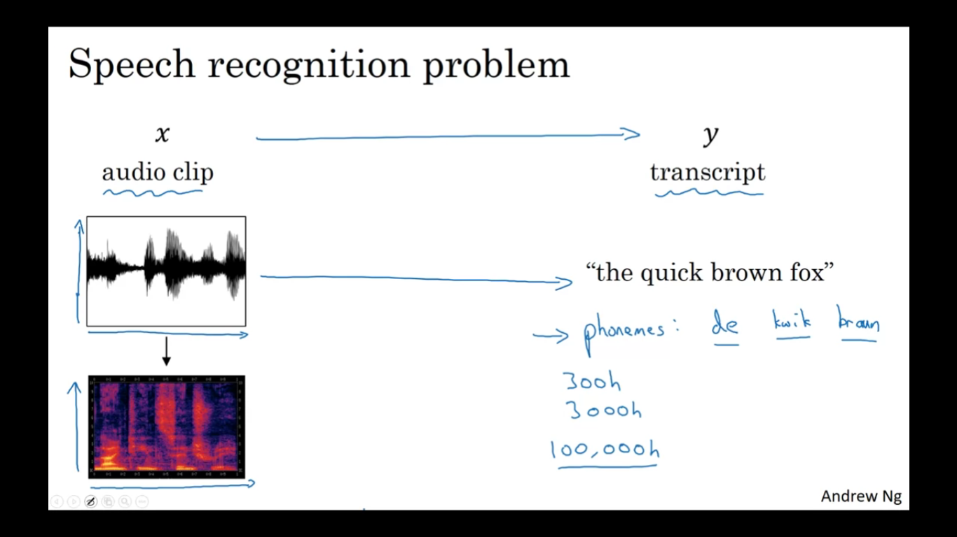

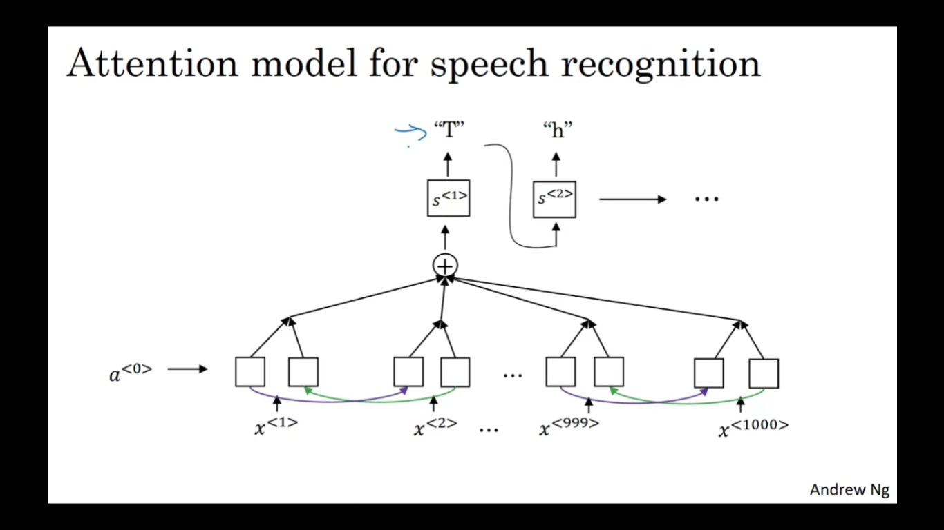

_ is a blank character in ctc model

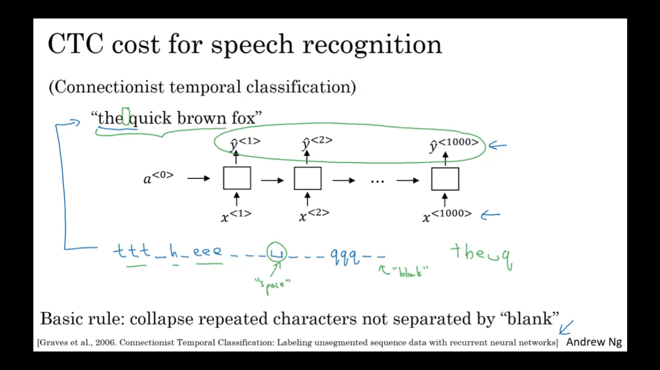

**9.Under the CTC model, identical repeated characters not separated by the “blank” character (_) are collapsed. Under the CTC model, what does the following string collapse to?**

__c_oo_o_kk___b_ooooo__oo__kkk

a)cokbok

b)cookbook

c)cook book

d)coookkboooooookkk

Answer: b